Some Notes on using TreeViewAdv version 1.6.0.0 in a VB.Net Application
This control is fairly easy to set and use but does not come with documentation and the way in which the tree is used is of necessity different from the basic .Net TreeView component. Some experience with the basic TreeView component is helpful but not a requirement.
To use this control in your own project you will need to copy the entire Aga.Controls directory from the supplied example to a new project and add it as a sub-project.
Note: The Aga.Controls is shipped with a strong name key and if you edit the code to add new functions you will find that it no longer works. You will need to remake the strong key. The error messages kicked up by VS2005 are a bit misleading as to the true cause.
For this example we will create a blank main form, and set the project properties to run this form after compilation.
Next create a User Control. Drag from the toolbox a copy of the TreeViewAdv control and make it a reasonable size. Add some buttons to the control surface for implementing your desired functions.
What I created looked like this:
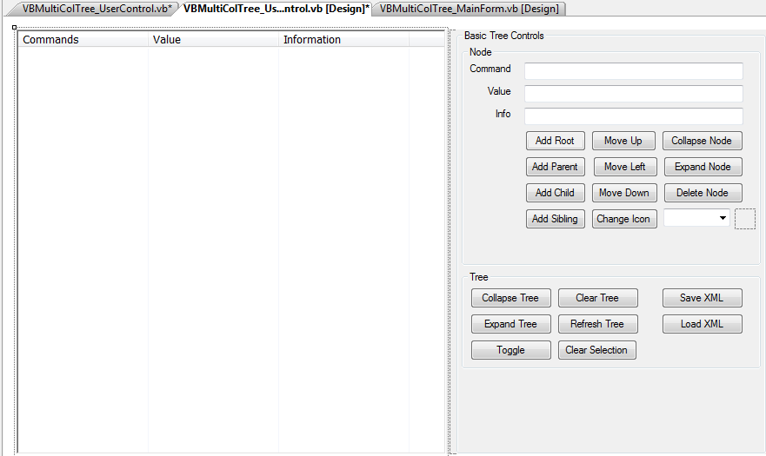
Next add some columns to your tree.
Find the columns collection and click on the […] to get the designer to show. Add three columns using the Add button. The names of the columns can be left as suggested by the designer. You will need to set the column header text though for each column. When done click OK.
You will also need to set UseColumns to TRUE otherwise your columns will not show up.

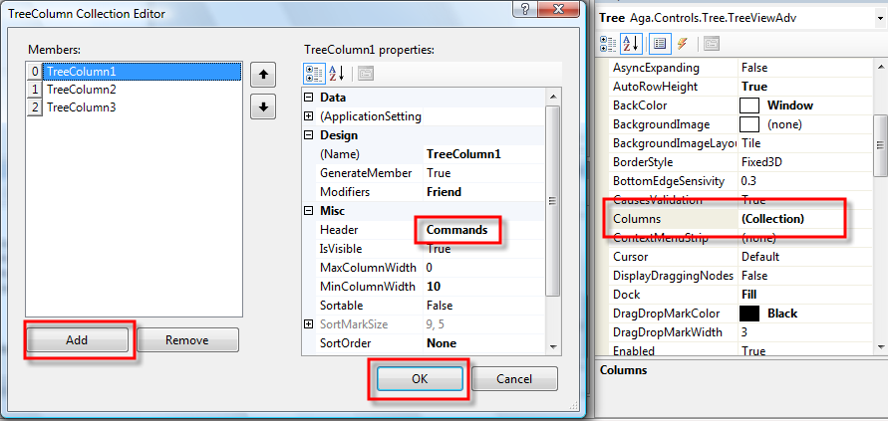
Next we need to put some data into these columns. This is done using the NodeControls Collection.
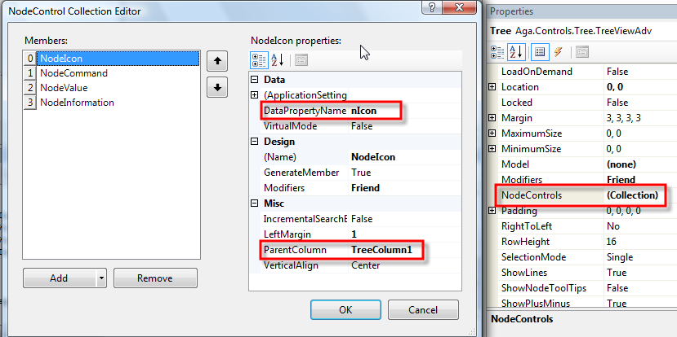
Activate the designer, and then add the nodes you want using the Add button. You will get a drop down list of the various possible node types. In this example I am using a NodeIcon.
You need to pay attention to the ParentColumn that you want this item displayed in, and the DataPropertyName that you want to refer to the data by. Without this you will not be able to access you data.
Add all the data nodes that you need.
To access these nodes we will need our own Node Class. This is based on the existing Node class. The properties in this class must match the DataPropertyName you have just defined.
Public Class VBMultiColTreeNode
Inherits Node

Next you will need to define the internal copes of the data for this call. These will then be accessed by the public properties.

Private _Command As String = ""
Private _Value As String = ""
Private _Information As String = ""
Private _Icon As Image
Private _ImageKey As String
Private _ImageList As ImageList

You will need one or more constructors to help when creating a new instance of your node.

#Region "Constructors"
Public Sub New(ByVal sCommand As String, _
ByVal sValue As String, _
ByVal sInfo As String, _
ByVal myImageList As ImageList, _
ByVal sImageKey As String)
nCommand = sCommand
nValue = sValue
nInformation = sInfo
_ImageList = myImageList
nImageKey = sImageKey
End Sub
#End Region

You will also need to define a property for each private member. Note that after a perty is set you should inform the model of the change.
#Region "Properties"

For a string value you can use code like this:
Public Property nCommand() As String
Get
Return _Command
End Get
Set(ByVal value As String)
_Command = value
NotifyModel()
End Set
End Property

For the Icon I used an ImageList with 24,24 size. I accessed the icons using the name of the icon as a key. You could also use the index number.
What is important here s that you must generate the bitmap yourself and stoe that in the node. This differes from Windows TreeView which only needs the icon number.
Public Property nImageKey() As String
Get
Return _ImageKey
End Get
Set(ByVal value As String)
_ImageKey = value
'now generate the bitmap from this key.
Dim bm As Bitmap = New Bitmap(_ImageList.Images(value))
_Icon = bm
NotifyModel()
End Set
End Property
#End Region

[Andrey.Gliznetsov]
The sample code above will produce a new bitmap instance for every node. Which is useless waste of memory. Instead of this I would use static method to return static instances of bitmaps based on icon name, or create a separate class(maybe singleton) to store bitmaps.
[/Andrey.Gliznetsov]

I also wanted to move nodes around, and for this I needed a way to clone a node so I added a method to do this. I also wanted to be able to express a node in XML for exportig and importing.

#Region "Methods"
Public Function Clone() As VBMultiColTreeNode
Dim NewNode As New VBMultiColTreeNode(_ImageList)
NewNode.nCommand = nCommand
NewNode.nValue = nValue
NewNode.nInformation = nInformation
NewNode.nImageKey = nImageKey
Return NewNode
End Function
Public Sub ExportXML(ByVal xtw As XmlTextWriter)
' xtw.WriteStartElement("VBMultiColTreeNode")
xtw.WriteElementString("Command", nCommand)
xtw.WriteElementString("Value", nValue)
xtw.WriteElementString("Information", nInformation)
xtw.WriteElementString("ImageKey", nImageKey)
' xtw.WriteEndElement()
End Sub
Public Sub ImportXML(ByVal xtr As XmlReader)
xtr.Read() 'step into the data itself.
' read the attributes in the correct order otherwise they get skipped over
nCommand = xtr.ReadElementString("Command")
nValue = xtr.ReadElementString("Value")
nInformation = xtr.ReadElementString("Information")
nImageKey = xtr.ReadElementString("ImageKey")
End Sub
#End Region

#Region "OverRides"
Public Overrides Function ToString() As String
Return _Command
End Function
#End Region
End Class
So we now have our own node class that knows about the names we defined in the tree. So we need to start using it.
The tree nodes are TreeViewAdv nodes, and your nodes are not the same. So how to get this to work?
The TreeView needs a MODEL and this is populated with your nodes.
' set up the tree with the model
_Model = New TreeModel()
Tree.Model = _Model
To add a root node you will need to do this:
Dim n As Node = New VBMultiColTreeNode(…)
_Model.Nodes.Add(n)

To select the tree item we need to find in which TreeView node represents our model node.
_Model.Nodes.Add(n)
Dim node As TreeNodeAdv = _Tree.FindNode(New TreePath(n))
node.IsSelected = True
_Tree.SelectedNode.ExpandAll()
Tree.Select()
To add a child node is also quite easy. First we must get the parent. Then we add an item to the parent’s collection
Dim MyNode As Node = Tree.SelectedNode.Tag
Dim n As Node = New VBMultiColTreeNode(…)
MyNode.Nodes.Add(n)

If you want to identify your node from the TreeViewAdv node then simply use the TAG property and cast it into your node.
Dim mn As VBMultiColTreeNode = DirectCast(_Tree.CurrentNode.Tag, VBMultiColTreeNode)
You can then use your node as your expect. To do the reverse use FindNode or FindNodeByTag methods. The node you find should have as a Tag the node your looking for.
To move an item to the left (i.e promotion in the tree structure) is very easy – all you have to do is assign a new parent to this node. The parts in yellow replicate this on the tree structures to be able to select the correct node after it has moved.
Dim Mynode As Node = Tree.SelectedNode.Tag
Dim Parent As Node = Mynode.Parent
If Parent IsNot Nothing Then
Dim TreeParent As TreeNodeAdv = Tree.CurrentNode.Parent.Parent
Dim GrandParent As Node = Parent.Parent
Mynode.Parent = GrandParent
Tree.SelectedNode = TreeParent.Children(TreeParent.Children.Count - 1)
Tree.Select()
End If

Moving a node up or down is more troublesome. Because it is actually only a pointer you will not get the effect you need by moving it. You will need to create a clone copy of the node to be moved, move all the children across to this node, and then delete the original node. The new node gets inserted into the correct place in the tree. As you do this the collection will later so you will need to do this in reverse. You cannot use a for each loop here as it will generate an error.
' now move the children across
For i As Integer = NodeToMove.Nodes.Count - 1 To 0 Step -1
NodeToMove.Nodes(i).Parent = NewNode
Next
The XML Export and Import use the streamwriter rather than the DOM model. Here it is adequate for my needs and the code is not large. I have hardcoded the values I need but you could use the properties collection to automate the entire process. Then all the parameters will be saved.
[Andrey.Gliznetsov]
You shoudn’t modify TreeView nodes directly, instead you should modify the model and fire event that model was changed. The TreeView will catch the event and redraw itself. See SimpleExample in the main solution.
[/Andrey.Gliznetsov]
There is one final thing you must do. You must create a main entry application form and place on it a copy of your control that you have just built. Then run the app to see how it works.

Richard Pope August 2007, Singapore

